**eCatering Industry**

**Stakeholders**

|  |  |
| --- | --- |
| **ACTOR** | **What they can do on the software created** |
| Employee/Customer | * Customers/employees can see the menu in the webpage. * Order their food directly from their workstations before 11 Am * Users can edit their order anytime before checkout * After checkout, they **can’t** cancel their order. * After delivering the food customers can write feedback * Employees Need to enroll for payroll system deduction before placing an order |
| Canteen Manager | * The canteen manager should be able to view the orders placed by the employees. * He can monitor and alter the food Menu based on the availability of Items. * The canteen manager can download the orders list to provide clear delivery instructions and information to the delivery boy including work station, desk number, and name of the customer |
| Delivery Boy | * The Delivery Boy needs to deliver food to the correct workstation, without fail, * The delivery boy needs to follow instructions and information provided to him, information regarding the workstation, desk, and customer/employee Department. * After delivering the order, the delivery boy needs to close the order. |
| Payroll system | * Payroll team can Obtain Information about employee/customer registered and Unregistered for Monthly deductions, * Payroll needs to calculate the total number of food items ordered by customers and do payment deductions for each employee |
| Management | * Management is responsible for * Provide in-depth reports on, * Sales for each day, which dishes are ordered more, and most popular dishes. * How many registered customers and, strong tracking on customer feedback, and satisfaction * Order forecasting i.e. a prediction of which items will be ordered and when they will be ordered. |

**Problem Definition and Solution**

* **Problem:** Below are some of the key findings of problems respective to Customers and the Canteen.

The problem for the Canteen is food wastage, Un-purchased food items, overcrowding in canteen at peak Hours, 12-1 pm, and run-out of items.

Problems for Customers are Time wastage, Limited menu, productivity Loss, Long Queues, No Seating, unavailability of Items, and Not getting a choice of food.

* **Solution:**

A canteen online order system helps the employees to order food online and get delivered to their workplace at a specified time and date. This solution can save time for customers, and it can cover all the drawbacks of canteen facing at present.

**Advantages and Objectives**

Advantages of the Canteen Ordering System:

* There are some advantages to Canteen and customers by using this Online ordering of food

**For the Canteen:** mainly Food waste was reduced by using this system, and improved customer service, easy payments for food items due to automatic deductions from payroll, and lesser crowd gatherings at peak times in the Canteen.

**For Customers:** Mainly this system helps customers to save time and increase their productivity, and the chance of getting their choice of food, delivery of food to their designated workstation, skipping long queues, and automatic monthly payment deductions.

**Objectives:**

* System focuses on Reduction in food wastage by 30% in the first six months of release
* Reduce Canteen operating costs by 15% in the first release within 12 months
* Increase employee productivity time of work to 30min per day within 3 months.
* By automated ordering process the restaurant can use less manpower to enhance its operating efficiency

**Existing System:**

The below image shows the current state analysis of the canteen ordering system in this process flow diagram As- Is model is used when Doing as-is analysis strong foundational information is required for better output and this As – Is model helps the organizations to find out how their current state process is going and helps to identify the opportunities for improvement.

According to the case study the customers face problems in various aspects of food and seating facilities, due to these reasons the customers are demanding an online food ordering platform, the opportunities will be discussed by using To-Be future analysis on upcoming pages

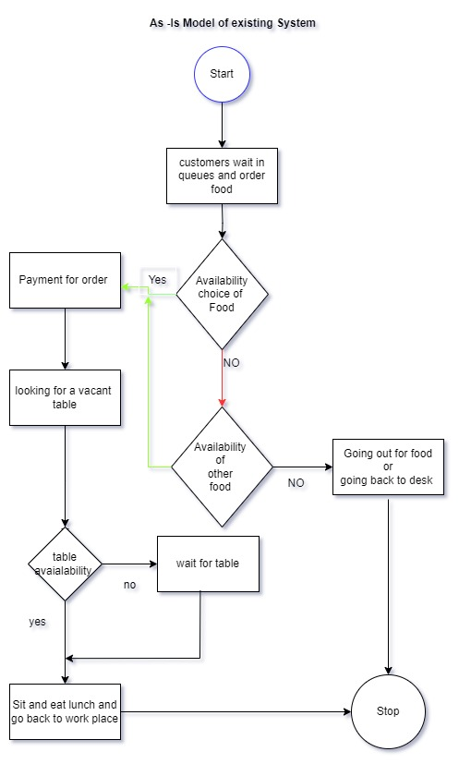

**Proposed System**

What is the proposed solution or system? Mention in points how the system itself will be for the user.

* User-friendly interface
* Up-to-date menu
* Order cut-off time by 11:am leads to a reduction in food wastage by not overcooking of dishes
* Enough time to prepare meals for the chef
* Menu manager or order processor can update the menu based on availability
* Website will be light and easy to render so it supports 1500 employees
* Delivery agents can deliver dishes to workstations
* By using this system management can gain a strong grip on activities
* No need of payment gateway, customers can order multiple times because of enrolment to payroll deductions

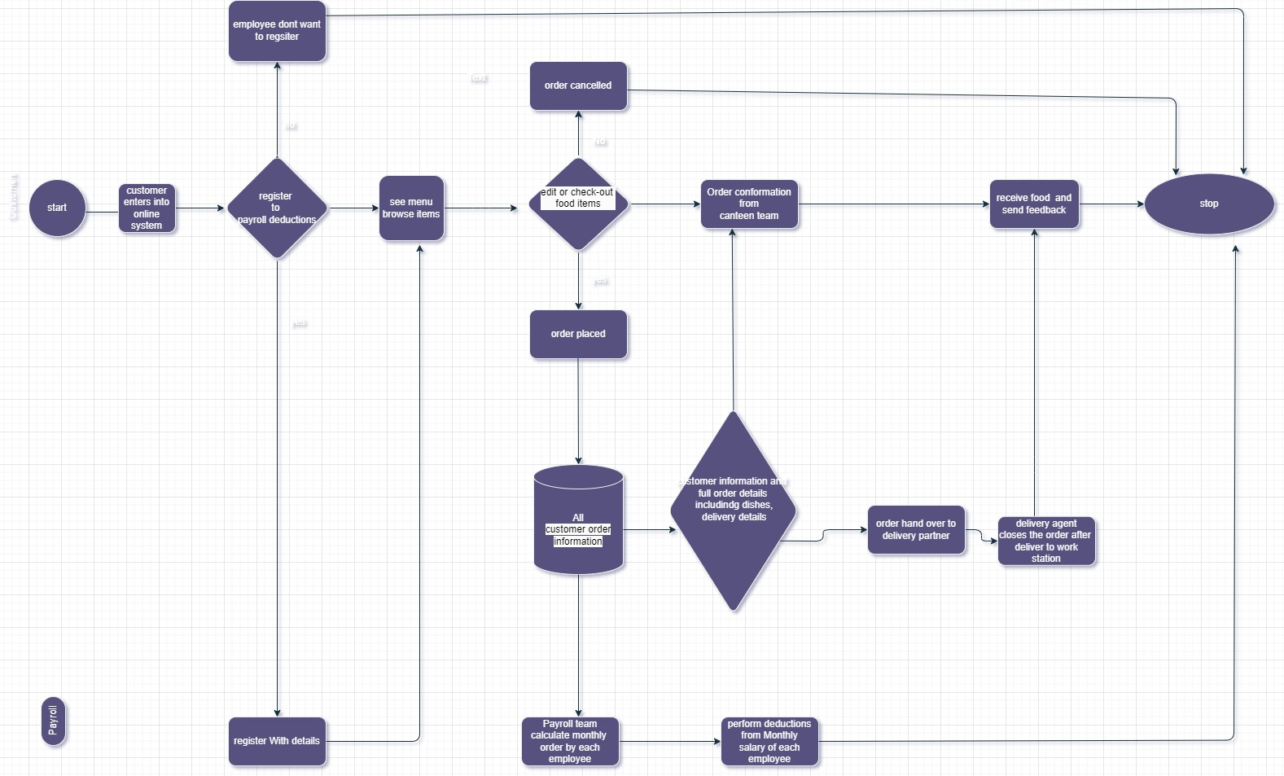**Scope using *use case diagram* (UML)**

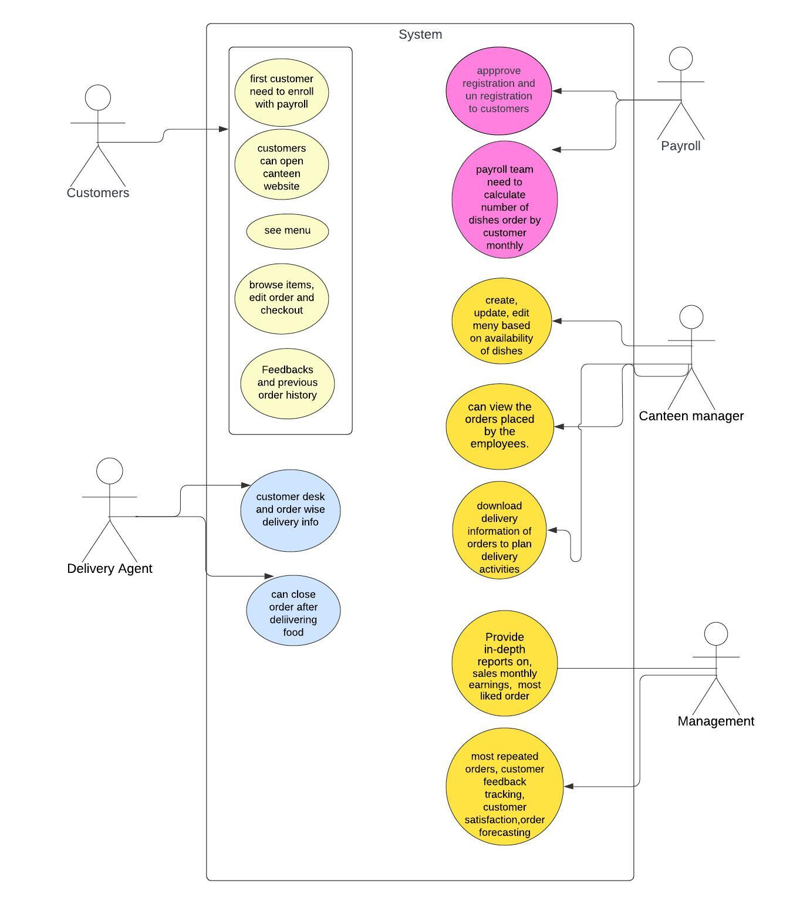

**Scope using *context diagram***

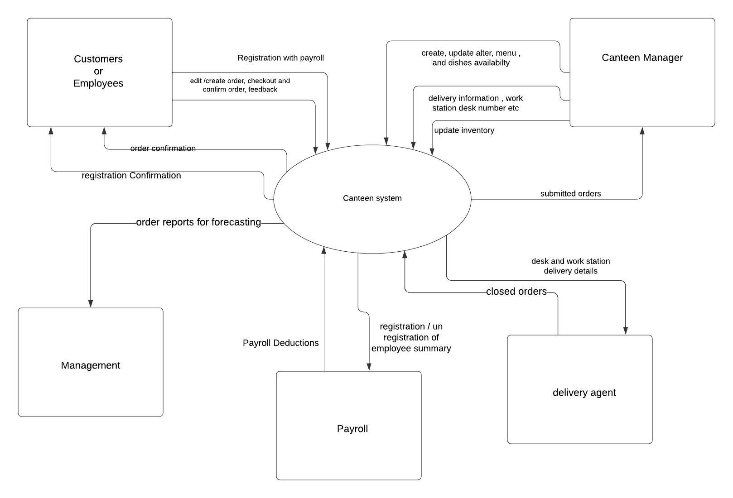

**In Scope**

According to the BABOk guide scope models act as a basis for defining the scope of business analysis work, the objectives, and the requirements of the client need to be addressed and complete the work.

The work and goals directly related to the scope come under In scope.

* Customers or employees can register and Unregister by using the system.
* The Customers can browse and see an updated menu whenever they open the webpage.
* The system allows the employees to create, edit, and finalize the order.
* The canteen manager can view the orders placed by employees within the system.
* Delivery boys can deliver the dishes to designated workstations and close the orders after delivery.
* Customers can give feedback about the dishes they ordered by using this system.
* Payroll can perform deductions for each employee based on their order history

**Out of Scope**

* System doesn’t accept any orders after 11 am
* After Checkout there is no option to cancel or edit the order
* Payment portal or payment gateway is not required
* System doesn’t ask for personal bank card details
* Live tracking is not available at present but may be implemented in future
* The system doesn’t allow to delivery of food to any other locations except workstations

**Activity Diagram for the System:**

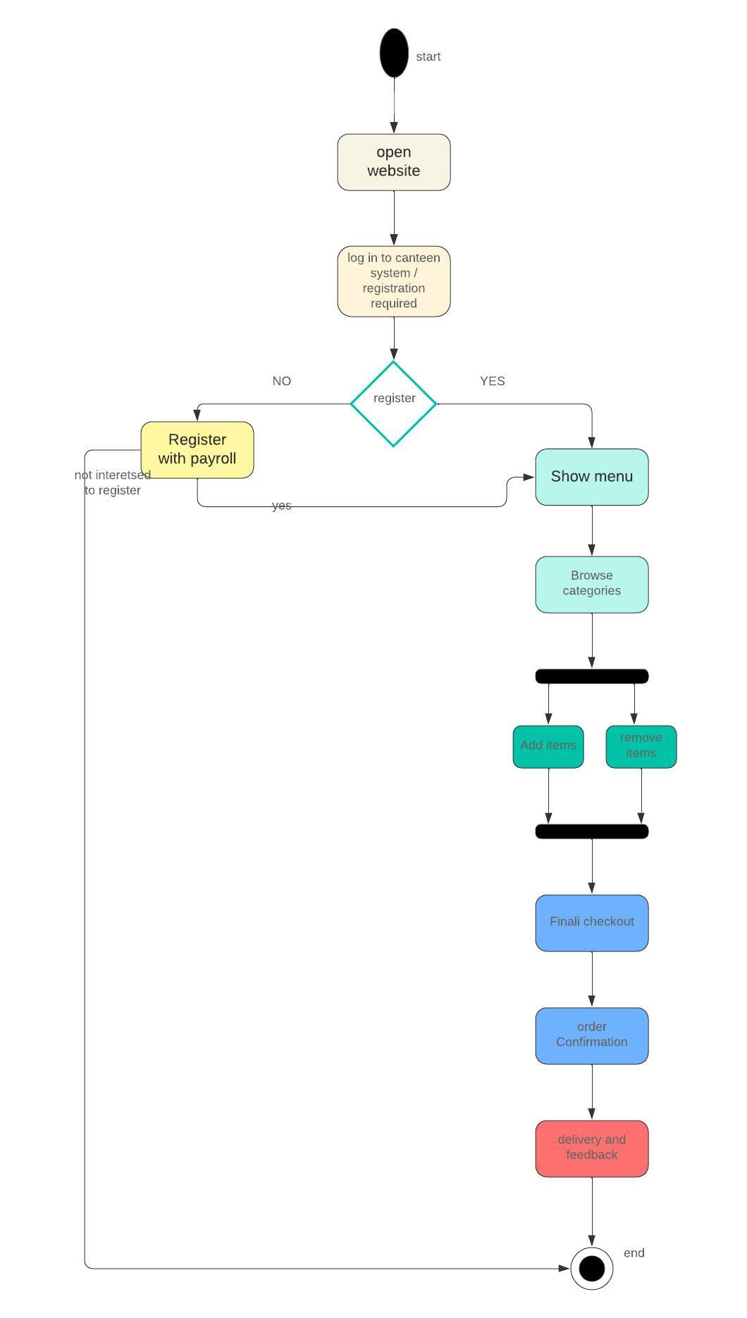

**ER Diagram for the System:**

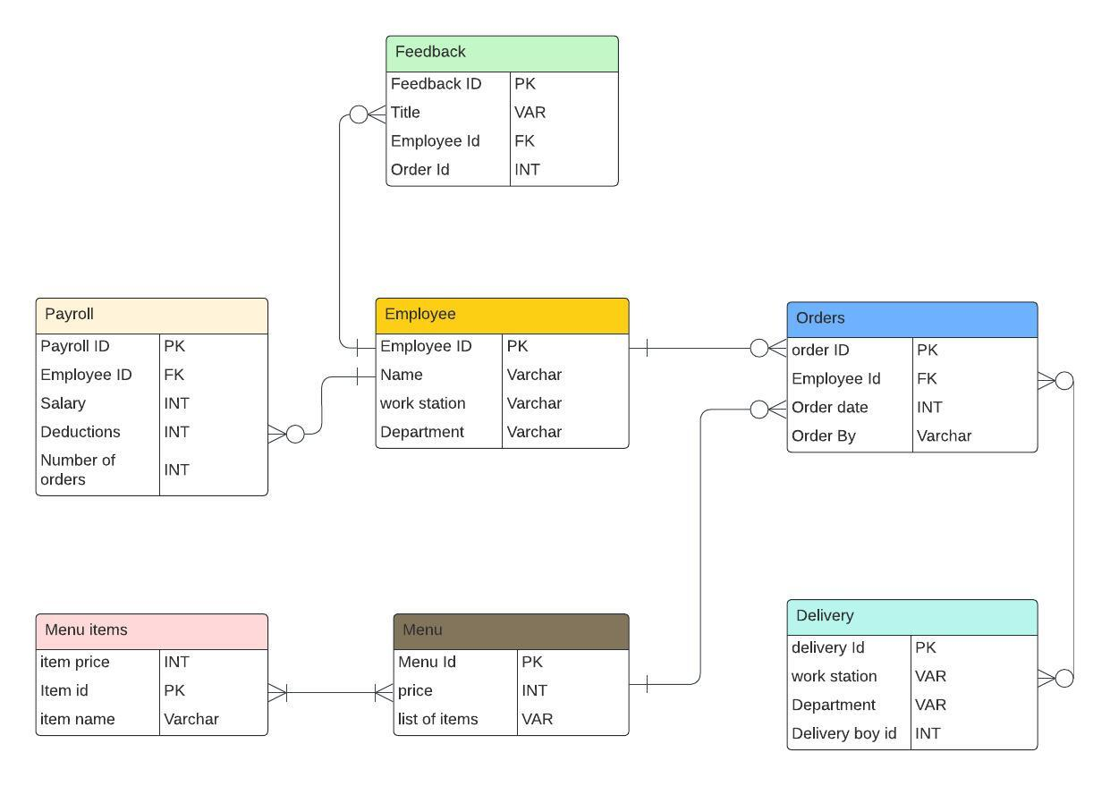

**Preconditions and Triggers: Example**

What user/manager should be able to do in a step?

Pre-conditions:

it is defined as that anything must be true to use a module functionality in simply the condition must be true before a use case to begin

* The user/employee needs to register with the payroll to get access to the website to order meals and other functions of the canteen ordering.
* The canteen manager needs to log in to create and update the menu.
* The canteen manager can summarize the orders that have been received
* The delivery boy should get all the information about order-wise delivery instructions

What are the triggers?

Based on the pre-conditions or events becoming true that causes the use case to begin.

* After registration customer gets access to place an order and browse the menu and food items
* The canteen manager can get a list of the total number of orders to be prepared or cooked
* A delivery agent can pick up the meals and summarize where to deliver the meals.
* What is the basic flow

Employees first register with payroll and order the meal, and after that canteen manager summarizes the orders and makes a list of orders to be prepared by 11 am

Following that the delivery agent delivers the meal to employees and closes the orders, after the customer can give feedback on the orders they received.

* What are the data elements?

Data elements are the different attributes that describe the data entity, the entity might be a unique id to identify various elements.

In the canteen ordering system, the data elements are

Customers, Orders, Menu, Feedback.

* In case of errors, what happens?

Contact the support team and raise a ticket.

**Business Requirements:**

**Business objective – 1:**

Reduce canteen food wastage by a minimum of 30% within 6 months following first release.

Scale: Value of food thrown away each month by examining the canteen inventory

* Previous - 25% wasted
* Must plan for: Less than 15%

**Business objective – 2:**

Reduce canteen operating costs by 15% within 12 months, following initial release.

**Business objective - 3:**

Increase average effective work time by 30 minutes per employee per day, within 3 months.

**Business objective - 4:**

By making the ordering process automated and by delivering the food to the user's workstation, the canteen will be able to operate with less manpower.

**Functional Requirements:**

Functional requirements of users/canteen manager /delivery boy/and management:

|  |
| --- |
| Functional requirements |
| FR-1 |
| FR-2 |
| FR-3 |
| FR-4 |

The system should only allow registered users to order meals from the website.

Customers can create accounts, log in, and recover their passwords.

The system allows customers to register and de-register anytime they want

The system helps the user to navigate to the main menu page after the registration is successful with payroll

The system allows customers to order meals up to 11: a.m.

The system allows customers to add one or more items to their orders

The system allows customers to remove one or more items before final checkout.

The system doesn’t allow customers to cancel their orders once placed.

The system allows customers to view their previous orders.

The system allows customers to give feedback on meals and services given by the canteen ordering system.

The system allows the manager to update and later the menu based on availability

The system allows the canteen manager to create a list of orders to be prepared

The system allows the canteen manager to view all the orders placed by the customers.

The system allows the canteen manager to download delivery information including the name of the employee, floor, and department.

Delivery boy can use the system to close the order after delivery to the customer.

The system allows the delivery boy to view a list of orders to be delivered.

The system allows payroll to perform deductions

The system stores data of previous order history to perform deductions by the end of the month and process deductions from salaries.

The system allows management access to download all the reports.

Most Popular Dishes.

Total number of employees using the system.

The satisfaction rate of employees' feedback.

Sales of each day

Total monthly earnings and order forecasting.

**Nonfunctional Requirements**

* Write all the nonfunctional requirements for the system.

|  |  |
| --- | --- |
| Usability  Availability    Reliability  Scalability  performance  Recoverability | The system should be self–explanatory and very user-friendly, and the interface should be with pictures.  The web page should be available on the intranet and Internet.  The system shall work on a company-based private network and company-based any authorized browsers.  The system should work stable and continuously every day throughout the year without any downtimes and support 1500 employees  The system should support 1500 employees to order meals at specific times 6:am to 11:am and support customers to order meals without any failure  The canteen ordering system can support a volume of 1500 employees  The website should be light and render fast for browsing and order placing.  The website can recover previous order information, customers' passwords, and other data to help and perform major tasks for management and canteen managers to solve the disputes and complaints raised by customers.  The system can be used by Unilever-authorized employees no outsiders have access to the website |

**Environments:**

**The entire website environment is running on Java code because it is easy to maintain and it will not change over time**

**WIREFRAMES:**

Here figma is used as a tool to make this login interface digital wireframe and menu digital wireframe.



